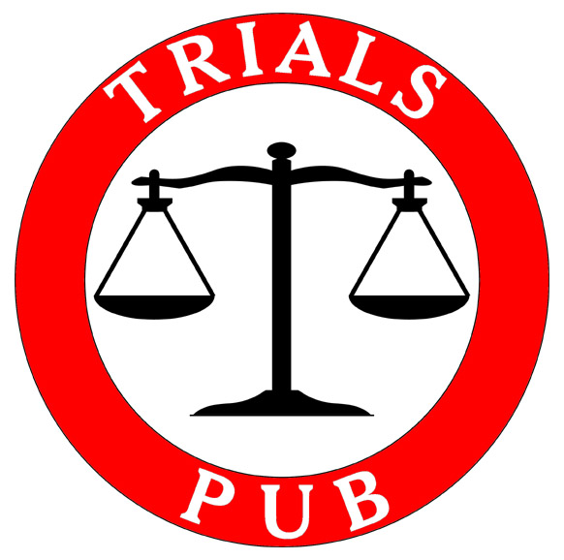

Trivia Quiz

09 FEBRUARY 2003

ANSWER SHEET
1. In the Chinese lunar calendar, the Year of the _____?_____ just began.

Answer: Monkey

2. What group made their US television debut on the Ed Sullivan Show on this day in 1964?

Answer: The Beatles

3. “Captain Kangaroo” died on January 23, 1004. What was his real name?

Answer: Bob Keeshan

4. Balltown, Beaver, Big Beaver, Blue Ball, Climax, Experiment, Intercourse, New Beaver, Peach Bottom, Porkey, and Virginville are all located in what State?

Answer: Pennsylvania

5. Match the Irish author/poet with his work:

1.__g___ The Picture of Dorian Gray a. Sean O’ Casey

2.__h__ Gulliver’s Travels b. Roddy Doyle

3.___a__ The Plough and the Stars c. William Butler Yeats

4.__f___ Playboy of the Western World d. Seamus Heaney

5.___e__ Portrait of the Artist as a Young Man e. James Joyce

6.__d___ Bogland f. John Millington Synge

7.__c___ The Wild Swans at Coole g. Oscar Wilde

8.__b___ Paddy Clark Ha Ha Ha h. Jonathan Swift

6. Where is the Sea of Tranquility?

Answer: The Moon

7. President G. W. Bush is the latest Republican president. Who was the first US President from the Republican Party?

Answer: Abraham Lincoln

8. Who was the first actor to portray Tarzan in a film?

Answer: Elmo Lincoln, 1918

9. Who coined the phrase “A man’s home is his castle”?
- Clarence Darrow
- Mark Twain
- Disraeli
- Winston Churchill
- Theodore Roosevelt

10. What is the world’s largest inland body of water, by area?

Answer: Caspian Sea

11. Identify this amendment to the US Constitution:
“Excessive bail shall not be required, nor excessive fines imposed, nor cruel and unusual punishments inflicted.”
Answer:Article VIII or the 8th Amendment

12. What British royal is currently visiting Iran, the first to visit since 1971?

Answer: Prince Charles

13. Who was the last British royal to visit Iran in 1971?

Answer: Prince Phillip

14. Who wrote the book “From Earth to Mars”?

- Jules Verne
- H. G. Wells
- Ray Bradbury
- Larry Niven
15. In the 76 years of the Academy Awards existence, only three films have swept all five categories in Best Picture, Best Directing, Best Actor and Actress, and Best Writing. You have been generously provided with a hint on the answer lines. They are:
Answer: 1934 It Happened One Night
Answer: 1975 One Flew Over the Cuckoo’s Nest
Answer: 1991 Silence of the Lambs

16. The Six Nations Rugby Tournament begins next weekend. Name the six countries involved:

Answer: England
Answer: Scotland
Answer: Wales
Answer: Ireland
Answer: France
Answer: Italy
17. Obligatory Shakespeare question: Which Shakespeare play has a character named Valentine?

- All’s Well that Ends Well
- Much Ado about Nothing
- Two Gentlemen of Verona
- As You Like It

18. Obligatory sports question: The New England Patriots won Super Bowl XXXVIII. What was the final score?
Answer: 32 -29
19. Which is the birthstone of February?

- Amethyst
- Pearl
- Bloodstone
- Beryl

20. Who is Nigella?

- A Spanish movie star
- A British chef
- A Kenyan athlete
- An Italian pop singer

21. What element on the Periodic Table of Elements is represented by the chemical symbol “Kr”?
Answer: Krypton
22. What James Bond film was retitled “007 Averted the Spy Plot” when it was released in the People’s Republic of China?
Answer: From Russia With Love
23. What is the internet country code for Switzerland?

Answer: .ch

24. What rocker was born Eric Clapp?
Answer: Eric Clapton
25. Who was the first African-American to be appointed to the US Supreme Court?
Answer: Thurgood Marshall
26. Who is credited with the following quote: "Injustice anywhere is a threat to justice everywhere"
Answer: Martin Luther King, Jr
27. On February 14th, 1929, the St. Valentine’s Day Massacre took place in what city?

- St Louis
- Chicago
- New York City
- Boston

28. True or False, Pope Gelasius declared February 14 St. Valentine's Day around 498 A.D.?

Answer: Tru

29. This weekend the finance ministers of the G7 met in what Florida city?

Answer: Boca Raton

30. Who was reputed to be the only US President to be arrested while in office? He was convicted of exceeding the Washington speed limit on his horse and was fined $20

Answer: Ulysses S Grant

31. Who did the Director’s Guild of America recognize as the best director of 2003 at their annual awards program this weekend?

Answer: Peter Jackson.

32. Goa is a state on the west coast of what country?

Answer: India

33. Dynamite was patented in 1867. Who was credited for this patent?

Answer: Alfred Nobel, Stockholm Sweden

34. Who wrote “The Martian Chronicles’?
Answer: Ray Bradbury

35. What Iranian city was devastated by an earthquake last month, killing over 40,000 people.

Answer:Bam

